Cybersecurity Engineering Approach

Revision
Version 2
6/5/25 10:34 AM

SME
Charles Wilson

Abstract
This document describes the general approach used to undertake the various activities specified by the AVCDL.

License
This work was created by Torc Robotics and is licensed under the Creative Commons Attribution-Share Alike (CC BY-SA-4.0) License.
https://creativecommons.org/licenses/by/4.0/legalcode

Overview
Product-level cybersecurity activities are typically considered in isolation. This is true of both cybersecurity practitioners and non-practitioners. It is easy to do for two reasons. First product-level cybersecurity evolved on an as-needed basis. Second, it is not widely appreciated that cybersecurity is an emergent property of the system.
Generally speaking, product-level cybersecurity currently uses a set of individual activities to address specific concerns within a system without regard to either overall workflow or process reuse.
From the standpoint of impact, arguably the most important group of cybersecurity activities are those which directly focus on the soundness of the software within the product. These activities lend themselves to a uniform engineering approach and that's what this document will address.

Workflow
AVCDL processes apply the workflow shown below.
Note: Unlike typical AVCDL process workflow diagrams, the actor, activity feedback, and report elements are excluded in order to focus on the topic at hand.
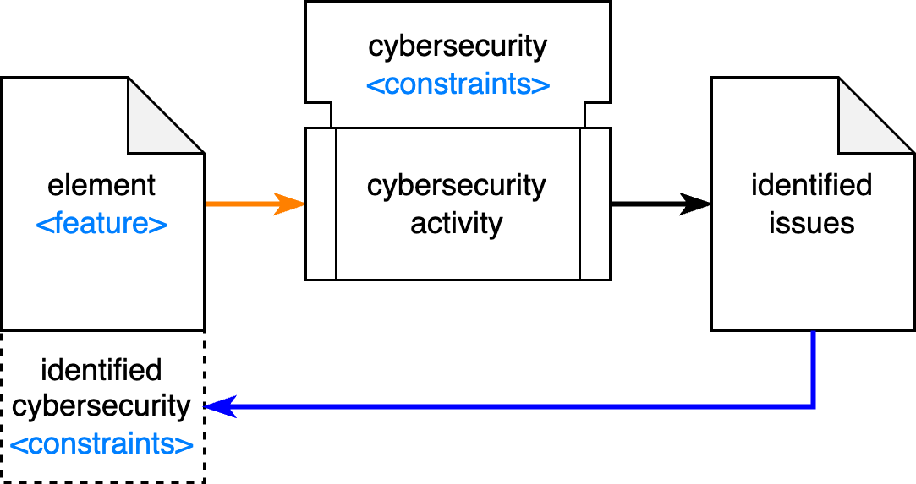
The cybersecurity activity takes as its input a feature of the element. This feature represents some aspect of the element which may be reasoned on for the activity. It may be a design, source code, functional requirements, or any other quantifiable aspect of the element under consideration.
The feature may be constrained by a set of identified cybersecurity constraints. These may be design principles, cybersecurity requirements, or best practices.
The cybersecurity activity could be requirements analysis, attack surface analysis, threat modeling, static analysis, dynamic analysis, secure code review, or any other appropriate activity.
The cybersecurity activity is governed, generally speaking, by a particular set of cybersecurity constraints.
These cybersecurity constraints are a superset of the identified cybersecurity constraints attached to the particular feature of the element under consideration.
The cybersecurity activity will result in a set of identified issues being created.
These identified issues need to point to specific cybersecurity constraints that either need to be attached to the element or be verified as actually having been applied to the element.
Note: It is not uncommon to have a constraint you know needs to be there and it doesn't happen to be in use.

Element Features / Cybersecurity Constraints
The following table details the element features and cybersecurity constraints applicable to various cybersecurity activities.
Note: Only those AVCDL processes most directly focused on the soundness of the product's software are included.
cybersecurity activity | element feature | cybersecurity constraint
requirements analysis ^{[2]} | functional requirements | requirements
design analysis ^{[3]} | design | design principles
attack surface analysis ^{[4]} | ports / protocols / processes | excess exposure
threat model analysis ^{[5]} | data flow diagrams | requirements
secure code review ^{[6]} | source code | development practices
static analysis ^{[7]} | source code | sound code practices
dynamic analysis ^{[8]} | compiled code | sound code practices
fuzz testing ^{[9]} | instrumented code | sound code practices
penetration testing ^{[10]} | operational system | see note below
Note: Penetration testing is an ad hoc activity where the testers utilize available information to attempt to induce failure states within an operational system. There is no established set of cybersecurity constraints by which this activity is governed. It has neither an industry (or regulatory) agreed upon set of defined outcomes nor metrics. It is included here for completeness.
Additional information regarding the specific element features and cybersecurity constraints for a given cybersecurity activity can be found within the applicable AVCDL secondary and tertiary documents.

References
- AVCDL (AVCDL primary document)
- Element-level Security Requirements (AVCDL secondary document)
- Security Design Review Report (AVCDL secondary document)
- Attack Surface Analysis Report (AVCDL template)
- Threat Modeling Report (AVCDL elaboration document)
- Secure Code Review Summary (AVCDL secondary document)
- Static Analysis Report (AVCDL tertiary document)
- Dynamic Analysis Report (AVCDL video)
- Fuzz Testing Report (AVCDL secondary document)
- Penetration Testing Report (AVCDL working material)

